# SEIMENS BROWSING DATA:

The data presented us with browsing activity of various customers and the purchase information of customers.

It was as follows:

### Conversions dataset contains the details of the customers to finally purchased from the site

* Timestamp: Order purchase timestamp
* user_id: unique identifier of the customer
* product_id: unique identifier of the product purchased
* cart_value: total cart value

### Browsing Behaviour dataset contains the overall browing in a particular day

* timestamp: time of the day
* user_id: unique identifier of customer
* browsing_url: website sections visited by the customer

The goal of this project is to observe the browsing activity of the customers and thus predict if these activity will convert into purchases.

# How to utilize the finding?

* Based on the various inferences made we can make educated decisions to increase our profit and decrease cost and resources.
* The model helps us to predict which of the potential customers that are browsing the products are likely to convert in to actual customers and make purchases. We can hence focus on these customers and spend our efforts in to retaining them.
* Additionally, we can also notice where the time spent in section result in a potential conversion. Primarily being “cart”, “product”, and “default” and “home” sections.

# How will the business benefit with accuracy?

* As the accuracy of a model increases. The reliability of the model will increase as well.
* When the model is more accurate, then the prediction made are more likely to come true and hence the focus towards increasing the customer based can be narrowed down to existing customers and such potential customers. This will lead to reduce in the cost of resources.

# Various useful inferences to boost business are:

* Out of all the customers browsing the products, it was noticed that 20.54% actually converted into purchasers. Our goal is to keep up these numbers and develop them along with browser activity to attract more customers.

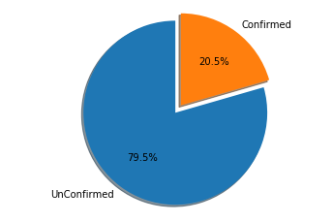

* The products that were responsible the maximum number of purchases were located and shown below. These products can be pushed forwards further and advertised as they are responsible for dragging in customers that may then follow and buy associated other products.

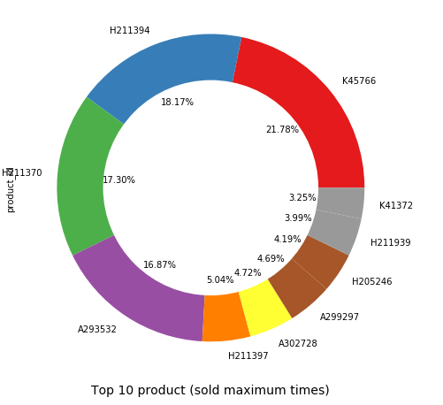

* We can see below the number of times a section of the website was visited by the customers on a single day.

The “Product section” is the most visited section as customers most likely to check about the product features and details, followed by the “product-listing-category” to choose which product they want to select.

These are parts that should be well developed and enhanced to encourage more activity.

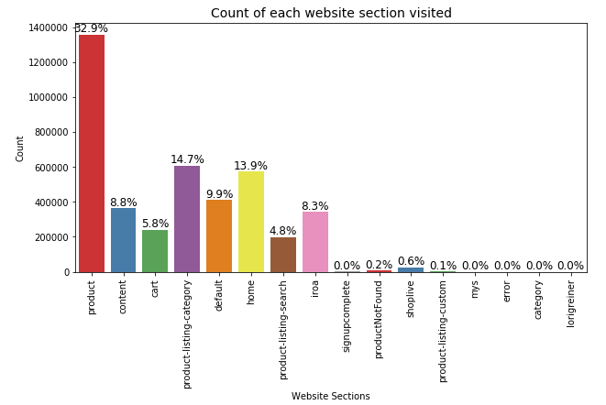

* The top customers in that visited the website were also located. Their

activity can be observed in order to attract similar customers and also locate which methods and strategies work in order to expand the customer base.

Basis on the number of transactions made, the graph below shows the top 15 customers. Also, keeping in view of these customers, in order to retain them efforts are to be made by providing offers, discounts and other such policies etc.

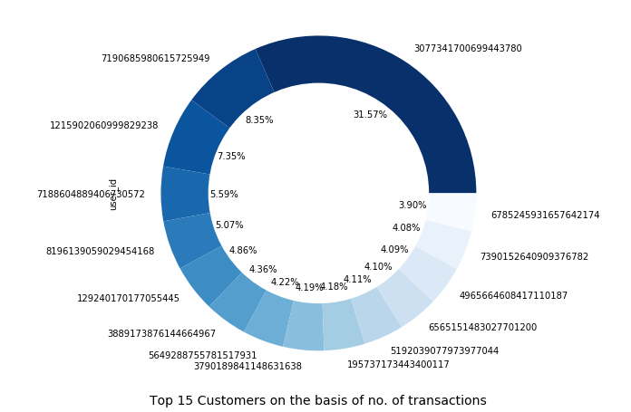

* The time where the activity is highest was observed, the maximum traffic on the website was found to be at the might time. Using these inferences special limited time offers can be offered to customers during these time windows to encourage them to make purchases with in these given time frames themselves.

The hourly browsing activity is shown below

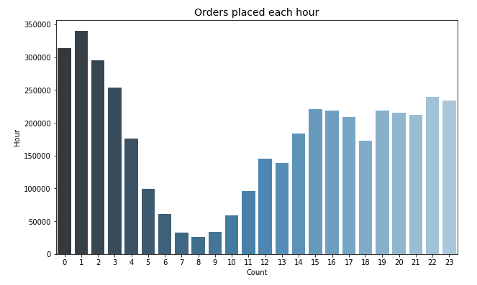

* After building the prediction model and analysis, the primary features that were found responsible for converting the browsing activities into purchases was the number of visits to the cart section, followed by the product section and then the default and home section.

From this we can conclude that, activity occurring in the cart section carried a very high significance and thus such customers that visited the cart multiple times, if given limited time offers, or other encouragements could be convinced to make purchases and increase revenue.

